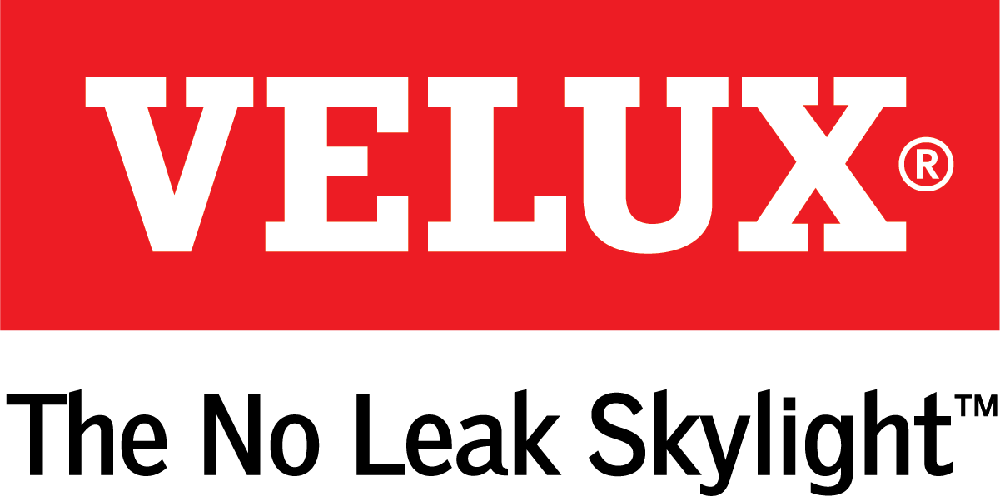
Media Contacts:
Kelsey Webb
704-790-1560
kwebb@wrayward.com

Dana Haydock
704-926-1301
dhaydock@wrayward.com

VELUX LAUNCHES “TO-DO, TA-DA” CAMPAIGN TO SHOW HOW SKYLIGHTS SOLVE COMMON DESIGN CHALLENGES

Natural Light and Fresh Air Through the Roof Make Rooms Feel Bigger, Brighter, Fresher, and Turn the To-Do List into a Ta-Da Moment

LAS VEGAS, Jan. 21-23, 2020 – When a room renovation or addition falls flat, even after a painstaking design process that includes choosing paint colors, furniture, finishes and hardware, skylights are a simple solution that bring the pizazz. With the launch of its “To-Do, Ta-Da” campaign VELUX Skylights offers a powerful reminder of the transformative quality of natural light and fresh air from above.
“In 2020, we are hoping to enlighten customers that by incorporating VELUX skylights into their home design, they aren’t just checking a box; they are transforming the box,” said Chan Hoyle, national marketing director for VELUX. “The ‘To-Do, Ta-Da’ concept captures the collaboration and tension that come with renovating a room in the home, and we believe this interplay will be relatable both for homeowners and the tradespeople who guide renovation projects.”
The “To-Do, Ta-Da” campaign includes three television spots showing couples negotiating what to include in the renovation of a kitchen, living room and bathroom. As wallpaper, tile and furniture fly onto and off of a room, the couples ultimately find inspiration in the ceiling, opening each room to the benefits of natural light and fresh air with skylights. The spots also weave in messaging about skylight automation with VELUX ACTIVE with NETATMO to educate consumers about the fact that skylights open and are an innovative home product.
“Many people forget to look to the ceiling for a simple design solution: adding skylights for natural light and fresh air,” Hoyle added. “Our focus group research revealed that many people don’t know that skylights can open for fresh air or that they can be automated using smartphone technology. When a room feels small, dark or stuffy, innovative VELUX skylights can be the one addition to create the dramatic transformation homeowners seek in a room renovation.”
The spots will air on HGTV, over-the-top streaming services like Roku and Apple TV, and in online advertisements throughout 2020.
See the first of the three television spots in the VELUX booth (C3307) at IBS, and for more information, visit www.whyskylights.com.

# # #

VELUX is the world leader in skylights and roof windows and is one of the strongest brands in the global building materials sector. VELUX products are available nationwide through home centers, building material suppliers, lumberyards and independent door, window or roofing retailers. Consumers can locate local suppliers and installers and access information on skylight selection and the benefits of bringing more natural light and fresh air into the home by visiting www.veluxusa.com or www.whyskylights.com. VELUX skylights are made in America in Greenwood, South Carolina.

